Adapting practice: Infection risk assessment and mitigation guide

This document provides a written record of the heightened infection control measures that this clinic has put into place to ensure the safety of all staff and patients during COVID-19.

This risk assessment and mitigation record should be undertaken in conjunction with review of the iO’s guidance ‘Infection control and PPE’ and ‘Adapting practice guide’ available from here. In this document you will find the following:

Table 1: This is an overview of the measures you have taken that will form your clinic policy for operating during COVID-19 and available to all staff and patients. This should be completed once you have undertaken an assessment of risk and detailed the mitigating action you have taken
  - NB: This does not constitute a full Health and Safety Risk Assessment as required by the Health and Safety Regulations for normal operation of business. Please see iO website for details of Health and Safety Policy, assessment and reporting an incident guidance.

- Table 2: Areas assessed for risk and mitigating action taken. This records in detail the areas of potential risk you have identified and record of the mitigating actions you have taken and when.
  - Table 2a - Protection for staff and patient before and when in clinic
  - Table 2b – Heightened hygiene measures

- Table 3: For completion to outline your PPE policy for staff in your practice

- Table 4: Detail of how you will communicate to staff and patients your policies

Please also ensure that you aware of the following:
General Osteopathic Council Interim Infection Control guidance for COVID 19

Completion of the attached demonstrates compliance with the following Osteopathic Practice Standards including but not limited to:
- A2: “…. adapting your communication to take account of [your patient’s] particular needs”
- C5: “You must ensure your practice is safe, clean and hygienic”
- D11: “You must ensure that any problems with your own health do not affect your patients”
We have assessed our practice for risks outlined and put in additional processes as detailed below

Undertaken a risk assessment | On 01/05/2020, Dr Jerry Draper-Rodi and Ms Patricia Sadler started undertaking a risk assessment and this has been an ongoing process since taking in account the change of Government guidance.
Heightened cleaning regimes | - The practice will be cleaned each morning when the practitioner arrives  - The clinic room will be cleaned between each patient  - Common areas/washrooms will be cleaned every 4 hrs  - Hard surface in common areas will be cleaned after every patient
Increased protection measures | - All linens from the clinic have been removed  - Only cashless payments are accepted  - Bookings are either made online or over the phone  - All staff will be equipped with PPE  - Osteopath’s temperature taken each morning when arriving to the clinic  - Each patient’s temperature checked when arriving on the premises and before entering the clinic room  - Patients are asked at the end of their appointment to let us know if they develop any COVID-like symptoms in the next 72 hours
Put in place distancing measures | - Appointments are staggered with other activities in the centre  - Patients will be asked not to enter the practice before 5 min before their appointment time  - Clinical notes will be completed after the patient has left the room to prevent them meeting the following patient and respect social distancing guidance  - Patients will not meet other people in the waiting area
Staff training | - Correct handwashing technique best practice  - Put on/remove PPE safely  - Staff briefed and trained on updated clinic policies and infection measures
Providing remote/ telehealth consultations | - All patients will have telephone pre-screening call  - Follow-up/maintenance appointments available via telephone/video call if possible
 | (Document last updated: 28/05/2020)

Table 2a. Protection of staff and patients before they visit, and when in, the clinic.
We have assessed the following areas of risk in our practice and put in place the following precautions to
 | Description of risk | Mitigating action | When introduced
Pre-screening for risk before public/patients visit the clinic | Infection  Group at risk  Moderate risk patients  Face-to-face consultation risks | Patients will be triaged when booking appointments:  - For high risk patients (shielding group) only remote appointments will be offered. People at high risk from coronavirus include people who:  - have had an organ transplant  - are having chemotherapy or antibody treatment for cancer, including immunotherapy  - are having an intense course of radiotherapy (radical radiotherapy) for lung cancer  - are having targeted cancer treatments that can affect the immune system (such as protein kinase inhibitors or PARP inhibitors)  - have blood or bone marrow cancer (such as leukaemia, lymphoma or myeloma)  - have had a bone marrow or stem cell transplant in the past 6 months, or are still taking immunosuppressant medicine  - have been told by a doctor they you have a severe lung condition (such as cystic fibrosis, severe asthma or severe COPD)  - have a condition that means they have a very high risk of getting infections (such as SCID or sickle cell)  - are taking medicine that makes them much more likely to get infections (such as high doses of steroids or immunosuppressant medicine)  - have a serious heart condition and are pregnant  - For moderate risk patients (clinically vulnerable), an assessment over the phone of their situation will be conducted. Remote consultations will be favoured, and if face-to-face appointments are warranted, we will try to offer them an appointment at the beginning of the morning or afternoon to prevent them meeting someone else and so that the room will have been aired for longer. People at moderate risk from coronavirus include people who:  - are 70 or older  - are pregnant  - have a lung condition that's not severe (such as asthma, COPD, emphysema or bronchitis)  - have heart disease (such as heart failure)  - have diabetes  - have chronic kidney disease  - have liver disease (such as hepatitis)  - have a condition affecting the brain or nerves (such as Parkinson's disease, motor neurone disease, multiple sclerosis or cerebral palsy)  - have a condition that means they have a high risk of getting infections  - are taking medicine that can affect the immune system (such as low doses of steroids)  - are very obese (a BMI of 40 or above)  If a virtual consultation does not meet the needs of the patient, patients (and chaperone if relevant) will be pre-screened before they arrive in the clinic:  - Screening for high risk patients  - Screening for COVID symptoms or exposure:  - Screening for any symptoms of COVID 19 (e.g. high temperature or a new, persistent cough) in the last 7 days  - Screen to see if a member of their household had/has symptoms of COVID-19 or are in a high-risk category  - Have they been in contact with someone with suspected/confirmed COVID-19 in last 14 days?  Patients will also be informed that PPE will be used by the practitioner and they will be asked to wear a mask (provided by the clinic). They will also be informed by email of the risk of face to face consultation.  The day before the appointment, patients will be contacted over the phone to assess if they have developed COVID-like symptoms since booking the appointment.  When arriving to the clinic, patients will use hydroalcoholic gel on their hands, will not touch handles (doors will be left opened) and will sit 2m away from the osteopath during the case history.
Protecting members of staff | Staff family members | Osteopaths at Osteopathy Abindgon are not and do not have a member of their household being in a vulnerable category.  The osteopaths will wear PPE in accordance to PHE guidance (glasses, apron, mask and gloves). See table 3 below.
Confirmed cases of COVID 19 amongst staff or patients? | Symptoms after appointment and lack of communication | If a member of staff starts feeling unwell, they will follow the Government guidance:  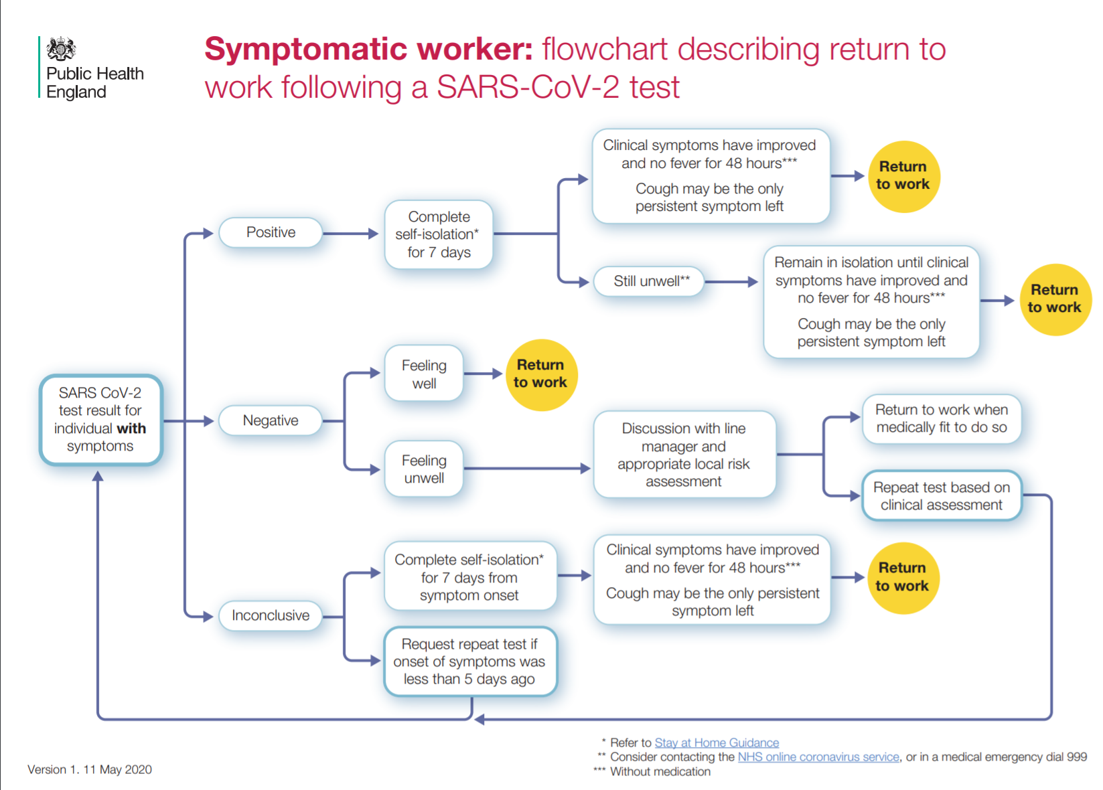  If a patient advises us that they have symptoms of COVID-19 after visiting the clinic (within 3 days), any staff with direct contact to that individual will self-isolate. Anyone with indirect contact with the patient, will be advised of the situation and suggest to monitor for symptoms.
Travel to and from the clinic | Arriving early in the waiting room and meeting patient booked earlier | Patients/chaperones will be asked to to wait in their car or in the car park until5 min before their appointment.
Entering and exiting the building | Risk of contagion by bringing COVID in the practice from home | - staff will change into work clothing at the clinic and place work clothing in a separate cloth bag to take home a home for washing  - patients will be asked not to arrive early or late for their appointment to avoid overcrowding and to comply with social distancing  - patients arriving early will be asked to wait in their car or outside the building (observing social distancing).  - patients will wash their hands (with either soap and water or a form of hand sanitiser) upon entering the building
Common areas | Risks of contamination by touching | - patients will be asked to turn up promptly at their appointment time to reduce time in the waiting area  - BACS payment instead of cash will be encouraged  - a virtual reception service is used
Social/physical distancing measures in place | Risk of meeting others and not respecting social distancing measures | - Staggered appointment times so that patients do not overlap in reception  - Only one practitioner and one patient (possibly one chaperone) on the premises at any one time
Face to face consultations (in-clinic room) | Risk during face-to-face appointments of transmitting COVID | - spacing between us and the patient increased to encourage social distancing when taking a case  - Some treatment techniques will be prevented to avoid unnecessary close proximity  - As much as possible, only one parent/guardian during visits for children  - No additional family members except if requested as a chaperone

Table 2b Hygiene measures
We have assessed the following areas of risk in our practice and put in place the following heightened hygiene measures
 | Description of risk | Mitigating action | When introduced
Increased sanitisation and cleaning | Risk for a patient to get infected from previous patient | - Clinic rooms - plinths, desk, door handles, equipment chairs - between each patient  - Waiting area - surfaces, doors and door handles, taps – at the beginning and end of the morning session and at the end of the afternoon session.  - Use of at least 60% alcohol sanitisers/wipes, and anti-viral product for floors  Actions to minimise the number of surfaces requiring cleaning  - unnecessary linen removed/ plastic pillowcases used that can be cleaned between patients  - clinic room and waiting area decluttered  doors between common areas kept open to reduce touch points
Aeration of rooms | Risk for a patient to get infected from previous patient | - Leaving the window open and the door closed for 15 minutes after each patient  - Removal of fans and other air-circulation mechanisms  Aeration of common/reception areas e.g. opening windows and or doors every 4-hour period
Staff hand hygiene measures | Risk for a patient to get infected from the osteopath | - Bare below the elbow  - hand washing before and after patients with soap and water for at least 20 seconds, including forearms/use of hand sanitiser gel  - hand washing before examination  - use of gloves during examination and treatment  - hand washing every time needs to touch another object (e.g. computer to read notes)
Respiratory and cough hygiene | Risk for a patient or the osteopath to get infected from each other | - Provision of disposable, single-use tissues waste bins (lined and foot-operated)  - Hand hygiene facilities available for patients, visitors, and staff

Table 3. Personal Protective Equipment
Clinicians will wear the following PPE | - Single-use nitrile gloves and plastic aprons with each patient  - Fluid-resistant surgical masks (or higher grade) changed every 4 hours or earlier if damaged  - Eye protection (glasses)
When will PPE be replaced | - When potentially contaminated, damaged, damp, or difficult to breathe through  - At the end of a session (4 hours)
Patients will be asked to wear the following PPE | - Fluid-resistant surgical masks even more if respiratory symptoms e.g. from hay fever or asthma  - Face-covering in clinical and waiting areas
PPE disposal | - Double-plastic bagged and placed in industrial waste at the back of the practice for collection.  - Cloths and cleaning wipes also bagged and disposed of with PPE

Table 4. Communicating with patients
Publishing your updated clinic policy | - Publish on clinic wall, available on request  - Provide as part of appointment confirmation emails  - Available on our website
Information on how you have adapted practice to mitigate risk | - Updating of website and via our social media accounts  - Email and e-newsletter to our patient base (in line with GDPR restrictions)
Pre-appointment screening calls | - Day before appointment  - The osteopath will call
Information for patients displayed in the clinic | - Door notices advising anyone with symptoms not to enter the building.  - Notices on other public health measures  - Posters in the waiting area on infection control measures in place

